Acceptance tests   
“Acme Rookies v1.0”

|  |  |
| --- | --- |
| Development team | |
| **Identifier** | *G92* |
| **Members** | *Batista Núñez, Francisco.*  *de la Flor Bonilla, Álvaro.*  *Fernández Benjumea, Carmen.*  *Ferrete Molle, José Antonio.*  *Salvat Pérez, Antonio Manuel.*  *Sanchez Hipona, Antonio.* |
| **Testing team** | |
| **Identifier** |  |
| **Members** |  |
| **Indexing data** | |
| **Test designers** | *Salvat Pérez, Antonio Manuel.*  *If you need to contact me:*  *antoniosalvatperez@gmail.com*  *+34 673 53 28 89* |
| **Testers** |  |
| **Notes** | *Use cases of R11.2/18.1 (Hacker-Rank)*  *Use cases of R4/R11.1(Rookies)* |

Dashboard

R11.2 -> 2. Display a dashboard with the following information: ♣ The average, the minimum, the maximum, and the standard deviation of the number of positions per company. ♣ The average, the minimum, the maximum, and the standard deviation of the number of applications per hacker. ♣ The companies that have offered more positions. ♣ The hackers who have made more applications. ♣ The average, the minimum, the maximum, and the standard deviation of the salaries offered. ♣ The best and the worst position in terms of salary

*R18.1 ->* *1. Display a dashboard with the following information: ♣ The minimum, the maximum, the average, and the standard deviation of the number of curricula per hacker. ♣ The minimum, the maximum, the average, and the standard deviation of the number of results in the finders. ♣ The ratio of empty versus non-empty finders.*

*R4 -> Display a dashboard with the following information: ♣ The average, the minimum, the maximum, and the standard deviation of the audit score of the positions stored in the system. ♣ The average, the minimum, the maximum, and the standard deviation of the audit score of the companies that are registered in the system. 2 ♣ The companies with the highest audit score. ♣ The average salary offered by the positions that have the highest average audit score*

*R11.1 ->* *1. Display a dashboard with the following information: ♣ The minimum, the maximum, the average, and the standard deviation of the number of items per provider. ♣ The top-5 providers in terms of total number of items provided*

Access

Log in to the system with an existing user of admin (admin/admin).

**Homepage > Header Menu > Login**

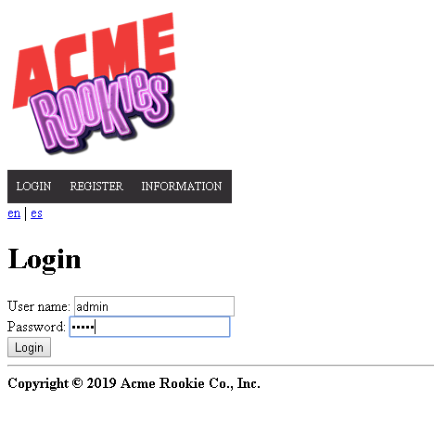

Browse through the available positions. Use the search form.

> Header Menu > Display the "ADMINISTRATOR" options > Dashboard

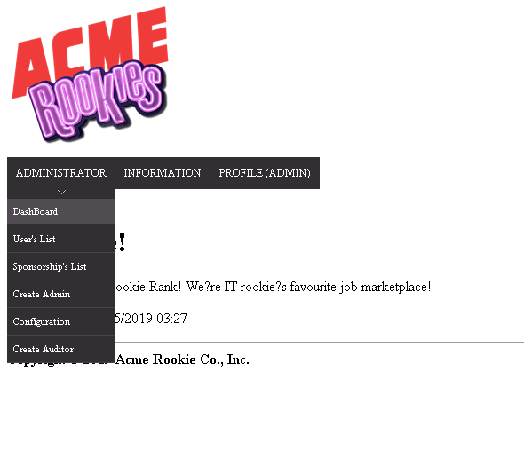

Tests

|  |  |
| --- | --- |
| Test 1 | |
| **Description** | *Check data* |
| **Expected** | *These are the results with the populate* |
| **Outcome** |  |
| **Notes** |  |

|  |  |
| --- | --- |
| Test 2 | |
| **Description** | *Enter with other actorr* |
| **Expected** | *We will check that the actors that aren´t admin can see the dashboard*  *This is the url:*  *administrator/dashboard.do* |
| **Outcome** |  |
| **Notes** |  |